# CS 340 README Template

**Marissa Lanza**

**2/1/2025**

## About the Project/Project Title

This application provides users with access to a database of animals, enabling them to create, read, update, and delete (CRUD) records for animals within the database. The primary goal of this project is to manage animal shelter's data and facilitate operations on the database, ensuring users can seamlessly add and interact with shelter data.

## Motivation

This project came about as part of my journey to better understand software development and databases. As someone who is self-teaching, it was really important for me to not just learn theory but to also put it into practice. I knew that building a CRUD application would help me understand how databases work, how to interact with them using Python, and how to structure an application that communicates with a database. It was an especially big step because I faced a steep learning curve, particularly when I ran into issues with MongoDB connections, and the Jupyter terminal was not cooperating as I expected.

This project became more than just an assignment; it was a test of my persistence. I was able to move beyond the roadblocks and see the benefits of my hard work when I finally got everything to work and got that “True” output in the terminal after testing the create method. It reinforced the idea that the most difficult challenges can lead to the greatest learning opportunities.

**Getting Started**  
*To get this program started, follow these steps:*

1. **Enter MongoDB and Import the CSV File**:  
   First, you need to enter MongoDB and import the aac_shelter_outcome.csv file to populate your database with shelter animal data.
2. **Create Indexes**:  
   After the data has been imported, you should create both a simple and a complex index on your collection to efficiently parse and query the stored data.
3. **Set Up User Authentication**:  
   Create both an **Admin** account and an **aacuser** account to allow users to authenticate and access the database.
4. **Install Python and Run the Program**:  
   To run the application, make sure you have Python installed on your machine. You can run the program using a Jupyter notebook.

**Installation***To run this program, you'll need:*

1. **Python**:  
   A current version of Python (preferably Python 3.x) is required to run both the .py and .ipynb files.
2. **MongoDB**:  
   MongoDB is necessary to store and access the animal shelter data. You can use MongoDB locally or opt for a cloud solution like MongoDB Atlas.
3. **Install Required Python Libraries**:  
   Ensure you have the necessary Python libraries installed. You can install them using pip:

**Usage**Here’s how the application works:

* **Create an Animal Record**:  
  Once the environment is set up and the MongoDB database is running, use the create method to add a new animal record. This method will return a boolean value indicating whether the animal was successfully added.
* **Search for Animal**:  
  You can search for an animal by its name using the read method, which will query the database for matching records.

### Code Example

*The code allows a user to test, add, and edit animals in a shelter. To test this a user would use. After starting mongo and loading the python files necessary to run the program a user could enter print(animals.create (STRING_TYPE) to add animals with the program throwing a boolean if it is successfully added or an error if not added.*

**Tests**

*This code was tested using an invalid statement of print(animals.create(0:0)) making an invalid argument as it tries to create an invalid data type.*

*To search for your added animal and ensure it was added one could use query = animals.read({”name”: “NAME”})*

### Screenshots

*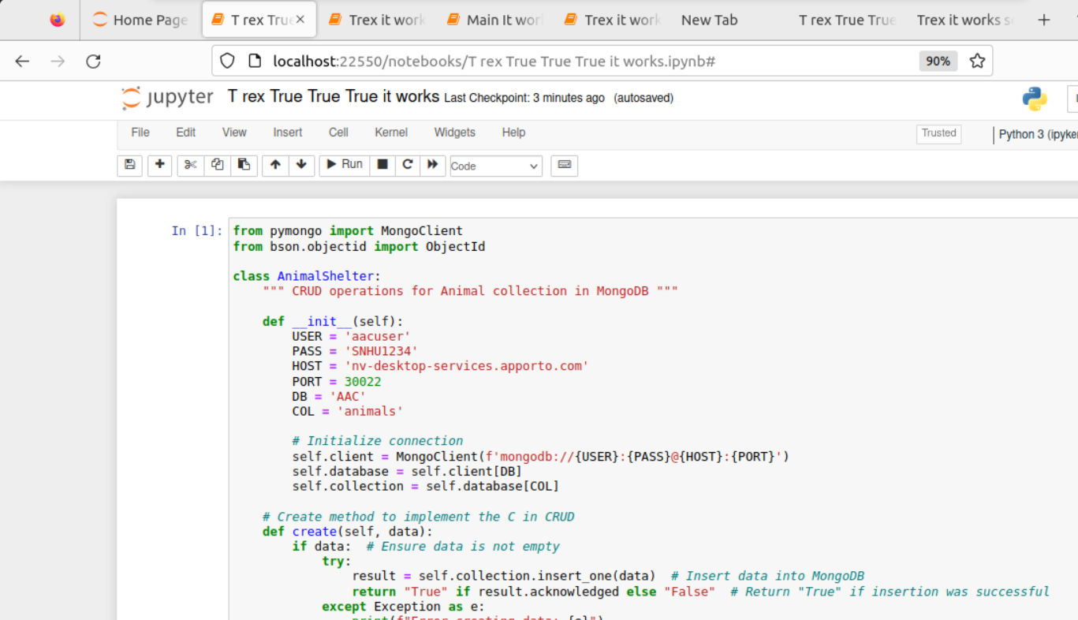Screen shots of T rex True True True*

## Screen shot of outcome, output is True.

## A screenshot of a computer Description automatically generatedScreen shot of T-rex before running.

Screen shot of Trex searching before running.

Screen shots of Searching T rex found database as shown below.

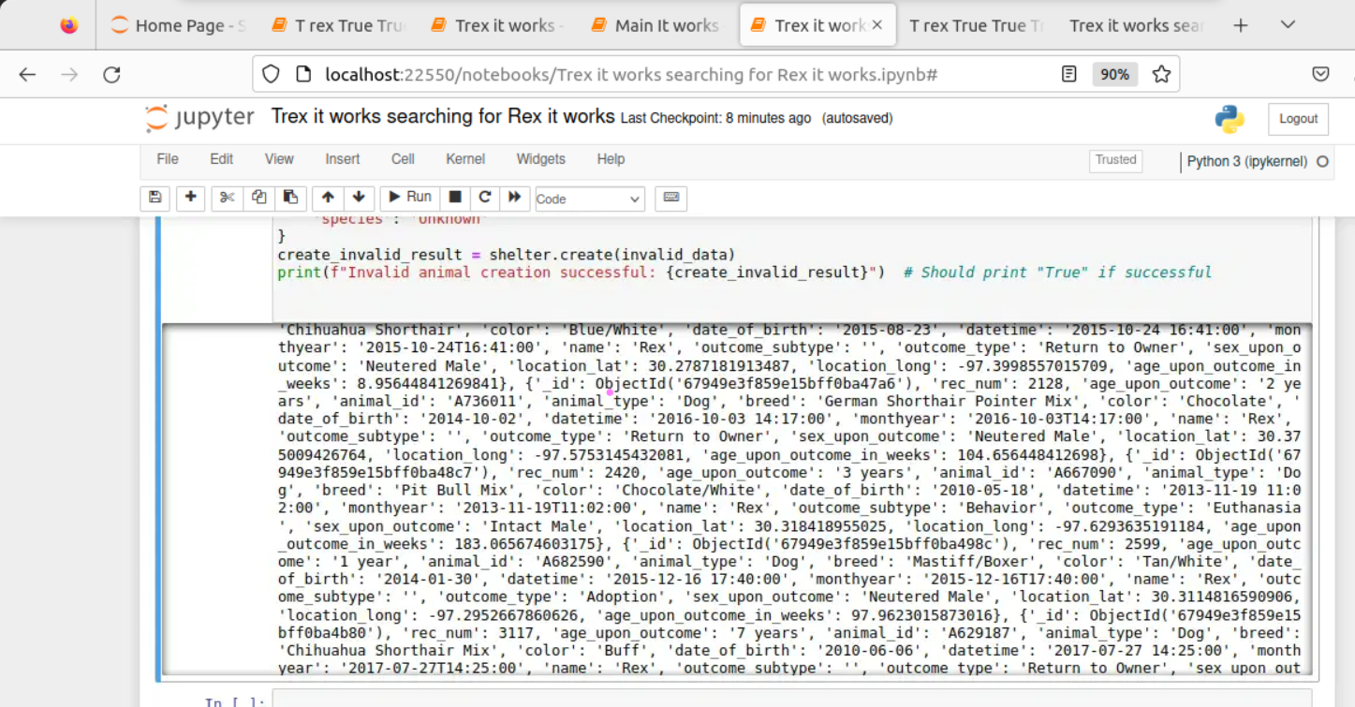Screen shot of Rex is found the database.

## Contact

Your name: **Marissa Lanza**  
Email: marissa.lanza@snhu.edu  
GitHub: <https://github.com/LiXiu37YaHua>

**Final Thoughts:**

The README is now more polished and structured for clarity, and includes the necessary details such as installation instructions, usage, and code examples. It also integrates your personal journey and reflections, which adds a personal touch to the document.

Let me know if you need further adjustments!